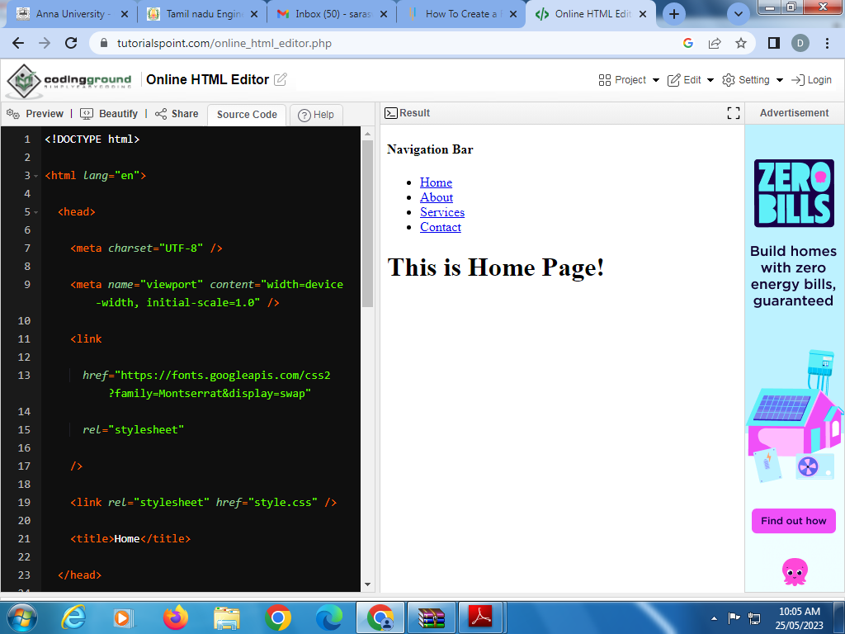

Program for navigation bar:

<!DOCTYPE html>

<html lang="en">

<head>

<meta charset="UTF-8" />

<meta name="viewport" content="width=device-width, initial-scale=1.0" />

<link

href="https://fonts.googleapis.com/css2?family=Montserrat&display=swap"

rel="stylesheet"

/>

<link rel="stylesheet" href="style.css" />

<title>Home</title>

</head>

<body>

<nav>

<div class="heading">

<h4>Navigation Bar</h4>

</div>

<ul class="nav-links">

<li><a class="active" href="index.html">Home</a></li>

<li><a href="pages/about.html">About</a></li>

<li><a href="pages/services.html">Services</a></li>

<li><a href="pages/contact.html">Contact</a></li>

</ul>

</nav>

<div class="body-text"><h1>This is Home Page!</h1></div>

</body>

</html>

<html>